FinalTerm Example Group 1 21-Dec-2023 8:30h

Name and ID :

MySQL : user root password DDB.123

Download backup file from Moodle. Extract zip file.

Restore DB from this file mysqlsampledatabase.sql

1. Insert 3 records for customers and employees

INSERT INTO employees (employeeNumber, lastName, firstName, extension, email, officeCode, reportsTo, jobTitle)

VALUES ('1287', 'Johnson', 'Michael', 'x4321', 'mjohnson@classicmodelcars.com', '1', '1056', 'Sales Representative');

INSERT INTO customers (customerNumber, customerName, contactLastName, contactFirstName, phone, addressLine1, addressLine2, city, state, postalCode, country, salesRepEmployeeNumber, creditLimit)

VALUES ('497', 'New Global Gifts Inc', 'Johnson', 'Michael', '5551234567', '789 Broadway', 'Suite 303', 'Los Angeles', 'CA', '90001', 'USA', '1287', '7500.00');

INSERT INTO employees (employeeNumber, lastName, firstName, extension, email, officeCode, reportsTo, jobTitle)

VALUES ('1288', 'Smith', 'Jennifer', 'x5432', 'jsmith@classicmodelcars.com', '1', '1056', 'Sales Representative');

INSERT INTO customers (customerNumber, customerName, contactLastName, contactFirstName, phone, addressLine1, addressLine2, city, state, postalCode, country, salesRepEmployeeNumber, creditLimit)

VALUES ('498', 'Global Collectibles', 'Anderson', 'Robert', '9876543210', '456 Main St', 'Suite 101', 'New York', 'NY', '10001', 'USA', '1288', '6000.00');

INSERT INTO employees (employeeNumber, lastName, firstName, extension, email, officeCode, reportsTo, jobTitle)

VALUES ('1289', 'Williams', 'Karen', 'x6543', 'kwilliams@classicmodelcars.com', '2', '1056', 'Sales Representative');

INSERT INTO customers (customerNumber, customerName, contactLastName, contactFirstName, phone, addressLine1, addressLine2, city, state, postalCode, country, salesRepEmployeeNumber, creditLimit)

VALUES ('499', 'EuroGifts Ltd', 'Brown', 'Alice', '8765432109', '789 Market St', 'Floor 2', 'Berlin', NULL, '10117', 'Germany', '1289', '8000.00');

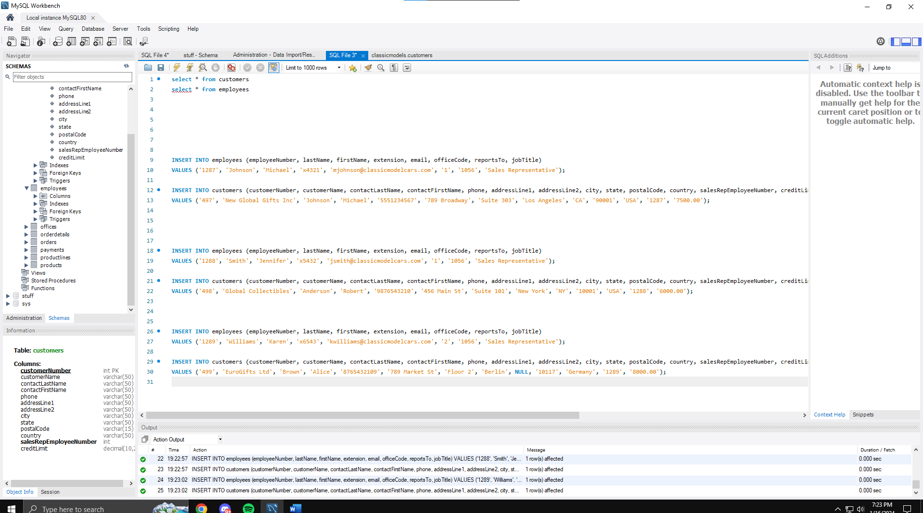

1. Update e-mail for Employee Diane Murphy to be [diane@uacs.edu.mk](mailto:diane@uacs.edu.mk)

UPDATE employees

SET email = 'diane@uacs.edu.mk'

WHERE lastName = 'Murphy' AND firstName = 'Diane';

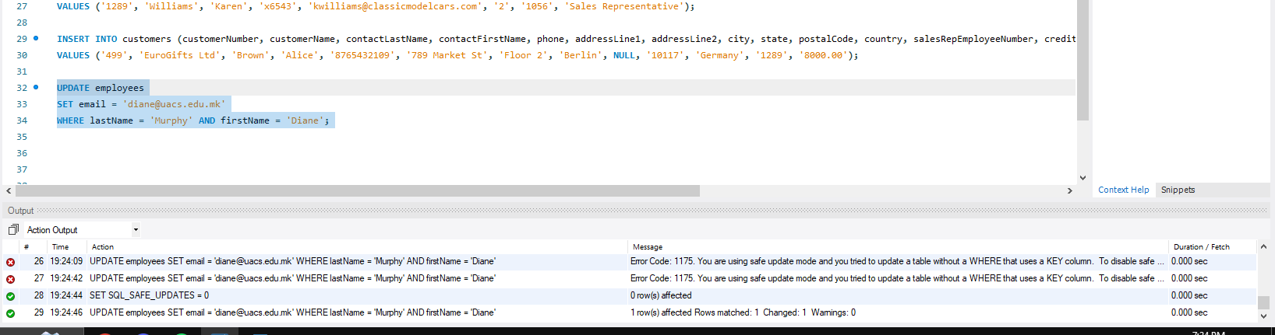

1. How many different countries we have in our DB (table customers)? Write sql statement

SELECT COUNT(DISTINCT country) AS num_countries

FROM customers;

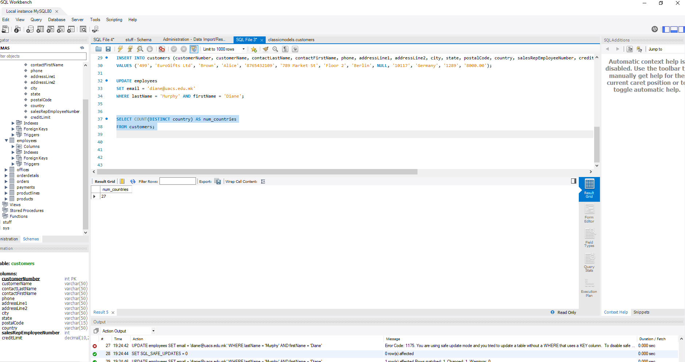

1. Create stored procedure to find all customers from USA and the country who is input parametar for the procedures

DELIMITER //

CREATE PROCEDURE GetCustomersByCountry(IN target_country VARCHAR(255))

BEGIN

SELECT *

FROM customers

WHERE country = target_country;

END //

DELIMITER ;

CALL GetCustomersByCountry('USA')

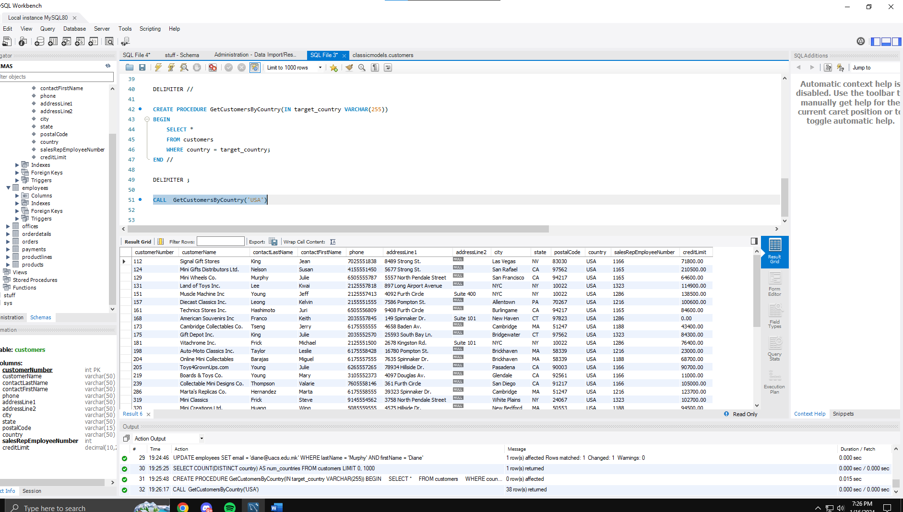

1. Create View to see all customers from Torino

CREATE VIEW CustomersInTorino AS

SELECT *

FROM customers

WHERE city = 'Torino';

select * from CustomersInTorino

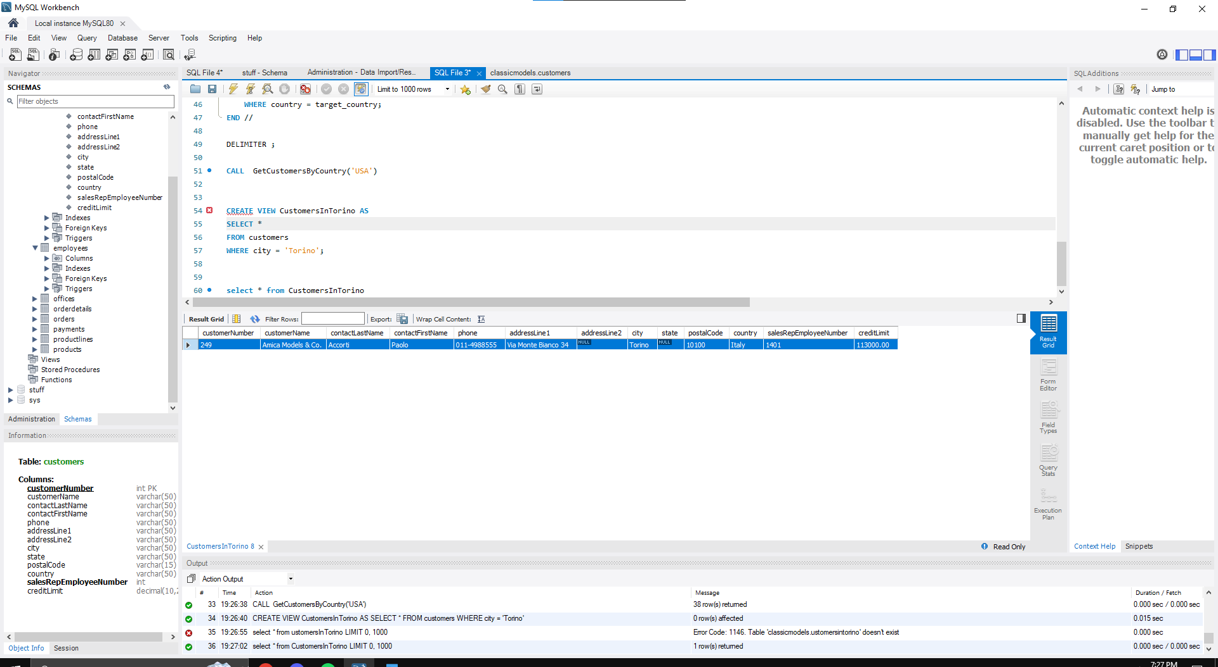

1. Create procedure that list all customers from some city (city is input parameter in the procedure)

DELIMITER //

CREATE PROCEDURE GetCustomersByCity(IN target_city VARCHAR(255))

BEGIN

SELECT *

FROM customers

WHERE city = target_city;

END //

DELIMITER ;

CALL GetCustomersByCity('Lyon')

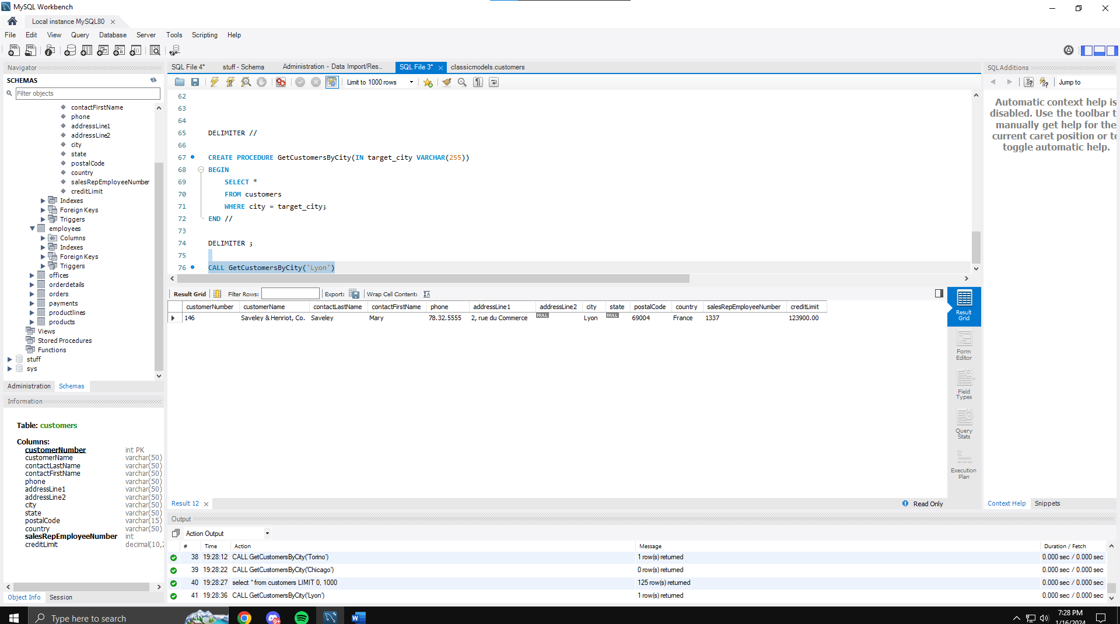

1. Create procedure that return customers (with Names) that have amount payment bigger than 6000

DELIMITER //

CREATE PROCEDURE GetCustomersByPaymentAmount(IN payment_amount DECIMAL(10, 2))

BEGIN

SELECT customerName

FROM customers

WHERE customerNumber IN (

SELECT customerNumber

FROM payments

GROUP BY customerNumber

HAVING SUM(amount) > payment_amount

);

END //

DELIMITER ;

CALL GetCustomersByPaymentAmount(1000.00)

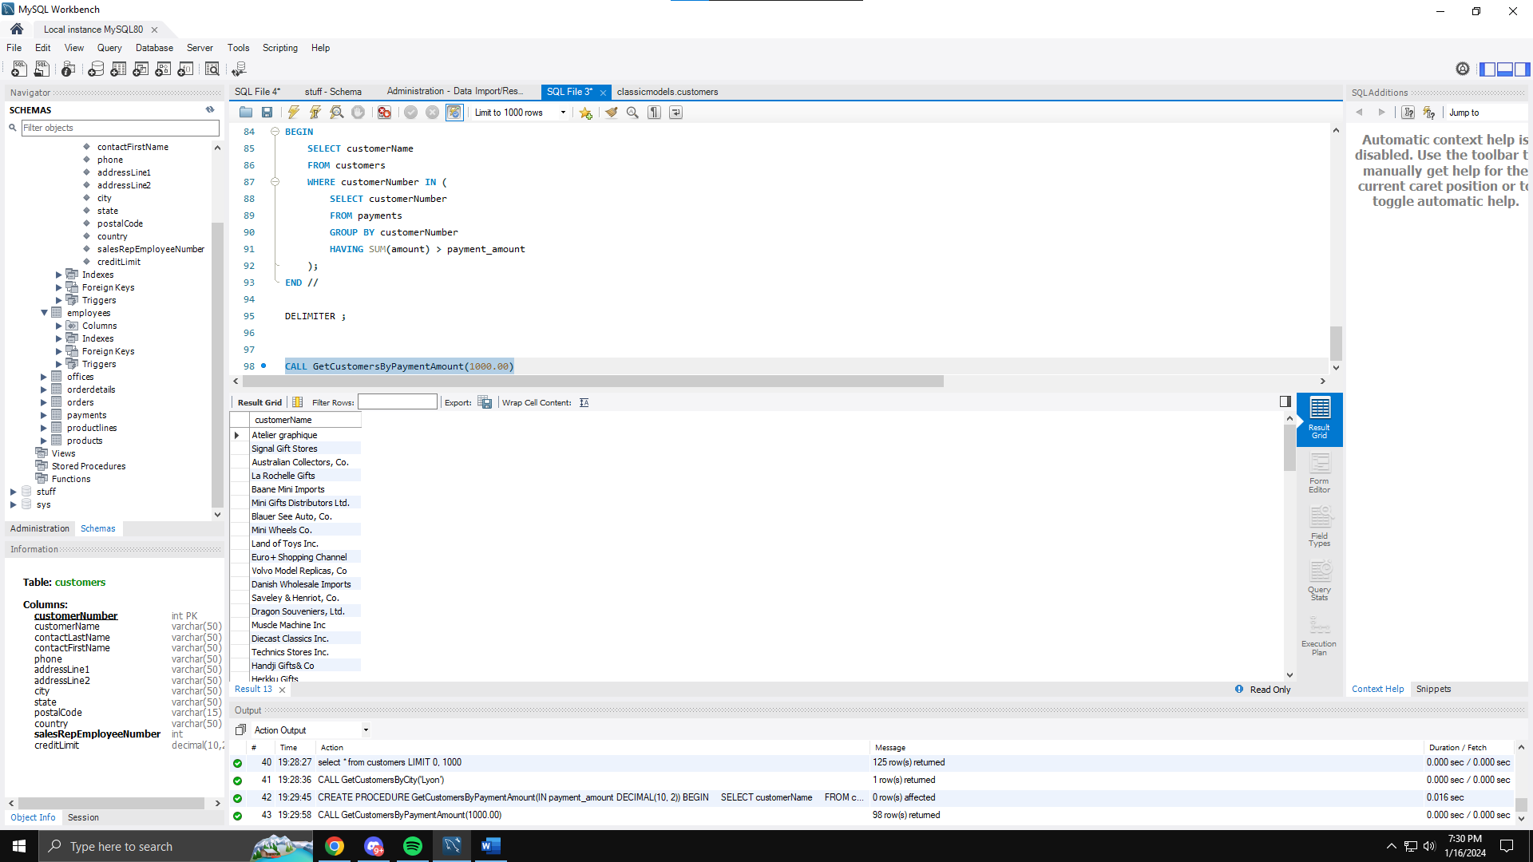

* 1. Modify procedure from step 7 , amount to be input parameter, and output parameter to be number of customers (for Home)

1. Create new DB and move only customers from Italy into a new table CustomersItaly

CREATE DATABASE IF NOT EXISTS new_database;

USE new_database;

CREATE TABLE IF NOT EXISTS CustomersItaly AS

SELECT *

FROM classicmodels.customers

WHERE country = 'Italy';

use new_database

select * from CustomersItaly

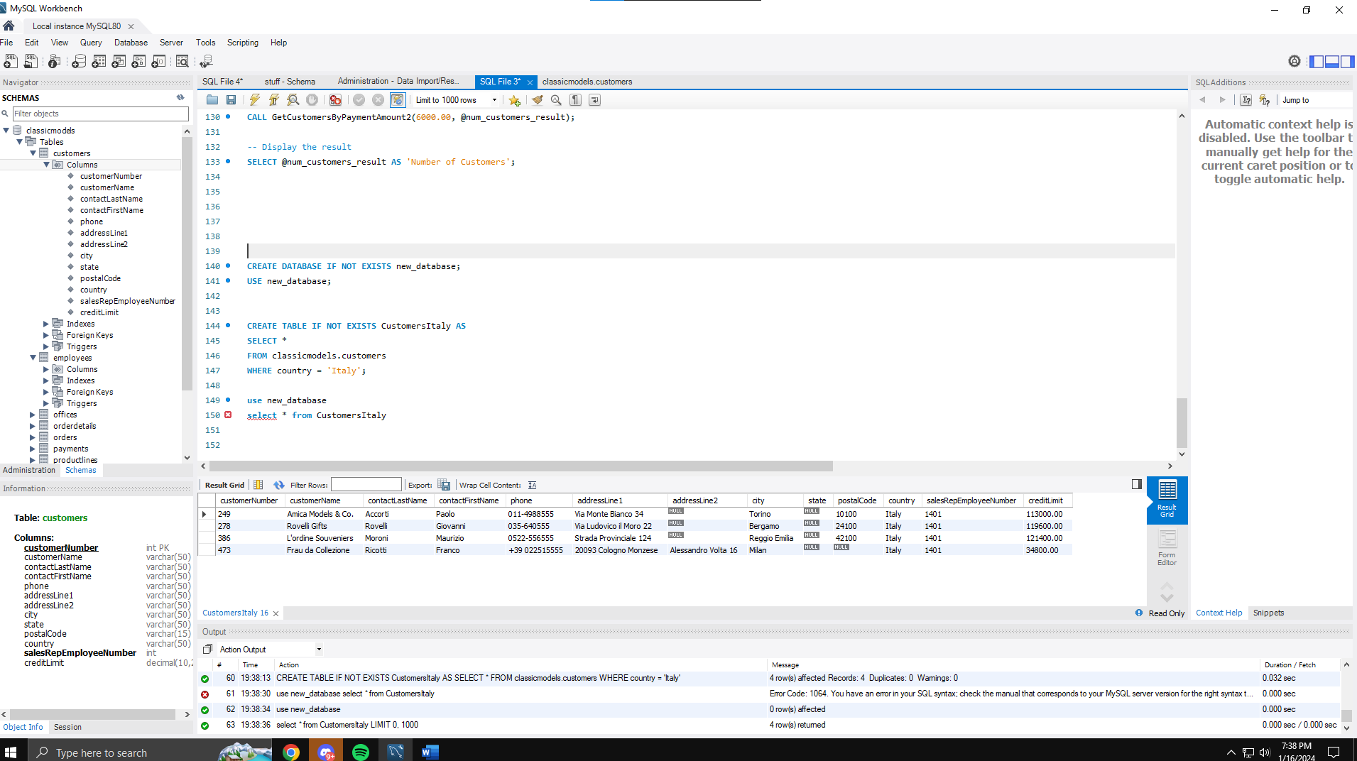

1. Crete trigger to catch before updates in table Employees (you need to have additional table for trigger execution)

use classicmodels

CREATE TABLE IF NOT EXISTS trigger_log (

id INT AUTO_INCREMENT PRIMARY KEY,

table_name VARCHAR(255),

action VARCHAR(255),

timestamp TIMESTAMP

);

DELIMITER //

CREATE TRIGGER before_update_employees

BEFORE UPDATE ON employees

FOR EACH ROW

BEGIN

INSERT INTO trigger_log (table_name, action, timestamp)

VALUES ('employees', 'update', NOW());

END //

DELIMITER ;

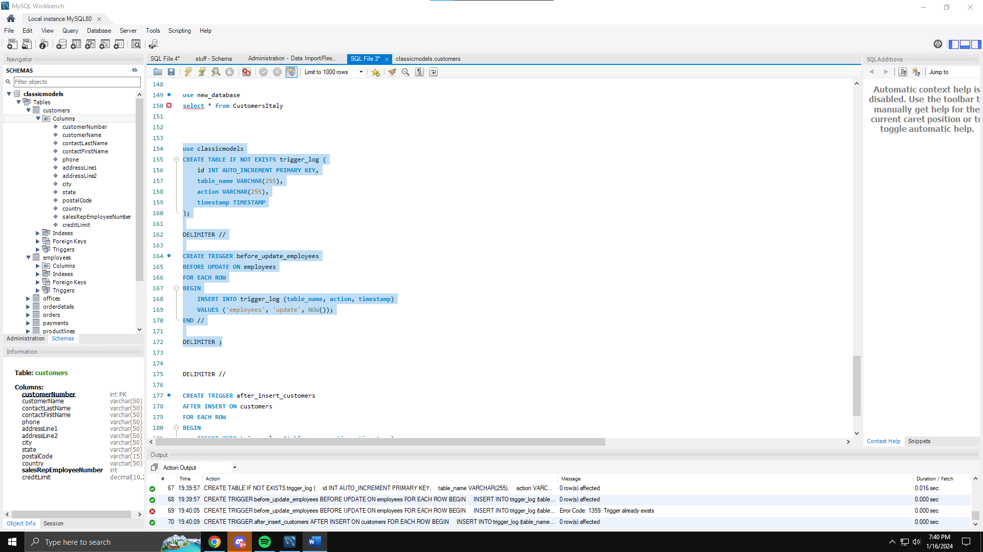

1. Crete trigger to catch after insert in table Customers (you need to have additional table for trigger execution)

DELIMITER //

CREATE TRIGGER after_insert_customers

AFTER INSERT ON customers

FOR EACH ROW

BEGIN

INSERT INTO trigger_log (table_name, action, timestamp)

VALUES ('customers', 'insert', NOW());

END //

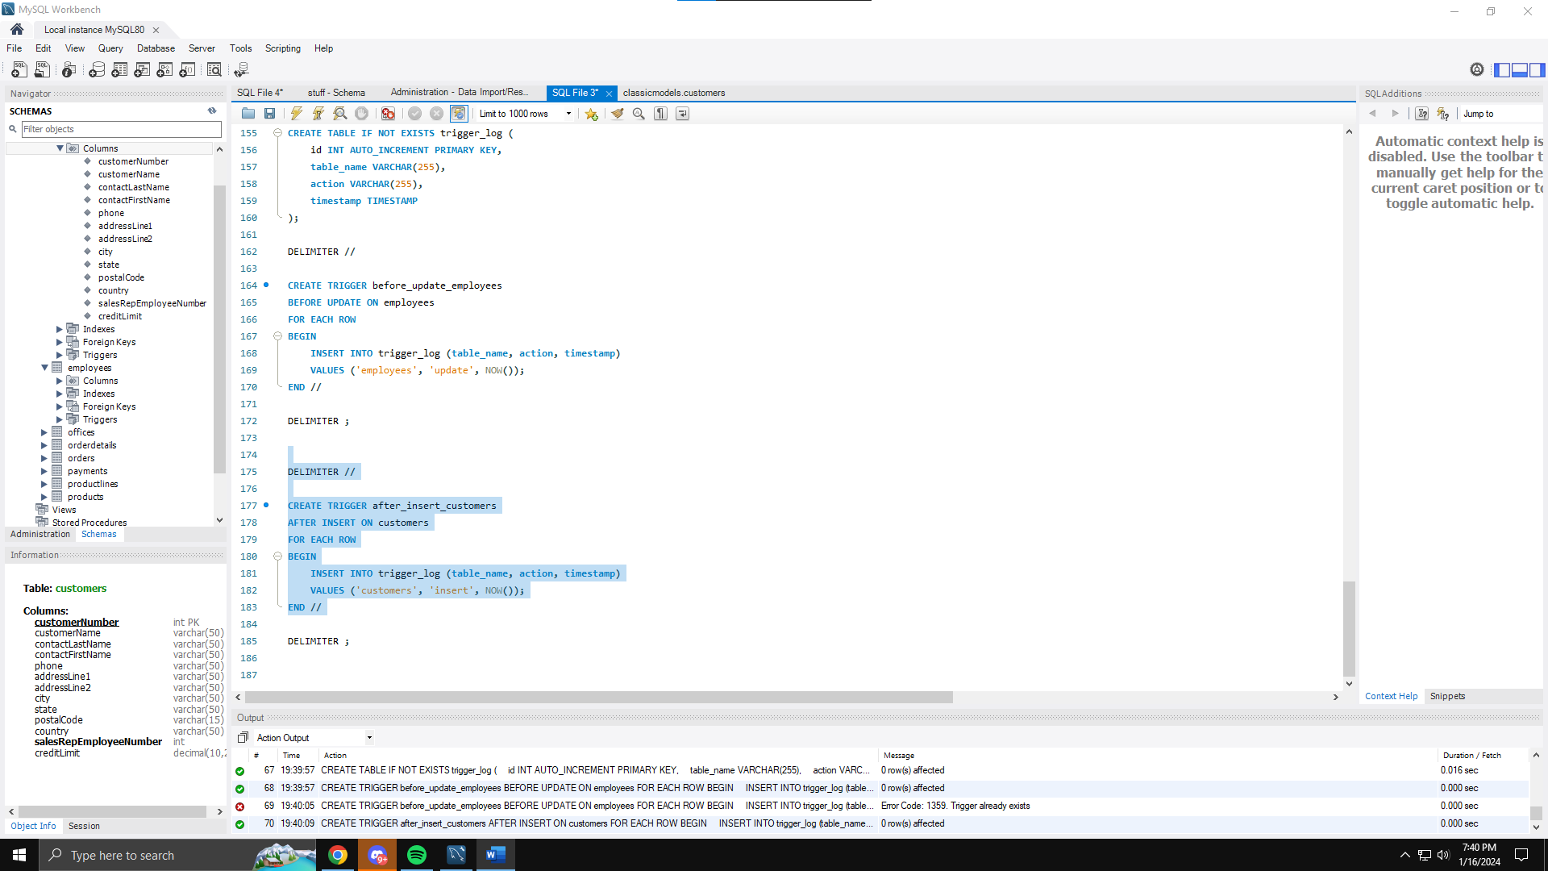

1. Create dump backup from working database

**MongoDB**

1. Create new DB FinalTermTest
2. Create 2 collections MySQL and MongoDB
3. Insert 3 rows in each collection

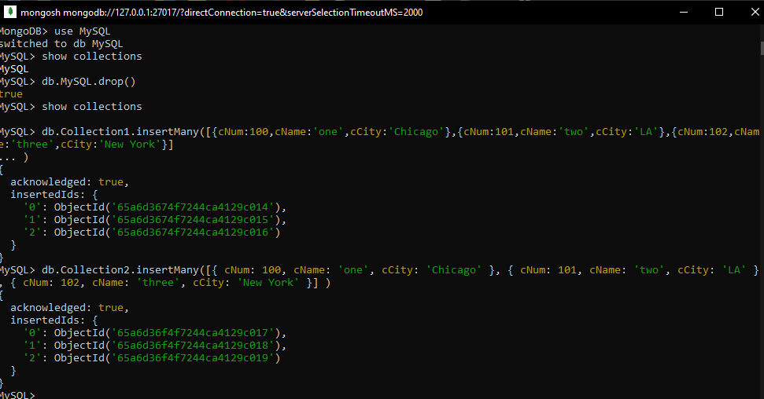

Note: for all steps you need to provide sql command, files and screens from successful execution. Test the triggers using appropriate insert/update statements. Send the word/pdf/txt file, table definition if you’re use additional table, views, trigger and store procedure definitions, output with info for the records from successful trigger test SQL query’s used for moved data to another DB.

Save all info in on folder ID and send thif zip file to [igor.janchev@uacs.edu.mk](mailto:igor.janchev@uacs.edu.mk)